Title of Abstract in Font Size 16.

Student Name

Research/Resource Group, Student Village, email.address@postgrad.manchester.ac.uk
School of Mechanical, Aerospace and Civil Engineering, University of Manchester, M13 9PL, UK

Please use this template to prepare your abstract. Your abstract should be 1 PAGE only. You should use size 12 Times New Roman font and replace the text on this page with your abstract. Please give your Resource Group, Student Village and email address above so that we can contact and find you.

Your abstract should be restricted to 300 words.

CONTENT: In your abstract, you should provide a concise summary of your work: describe the main area of research, the main application area, the methodology, etc. Your abstract should be easy to understand by your fellow PGR students. Importantly, explain the novelty of your research and project. You should, if possible, attempt to include evidence of your results such as shown in the example Figure 1 below. You may include references such the examples below [1-2]. The 300-word limit does not include Figures or references.

You should discuss your abstract with your supervisors BEFORE submitting.

DEADLINE: please submit your abstract by 30th January 2015 by emailing a pdf version to PGRmaceshowcase@manchester.ac.uk

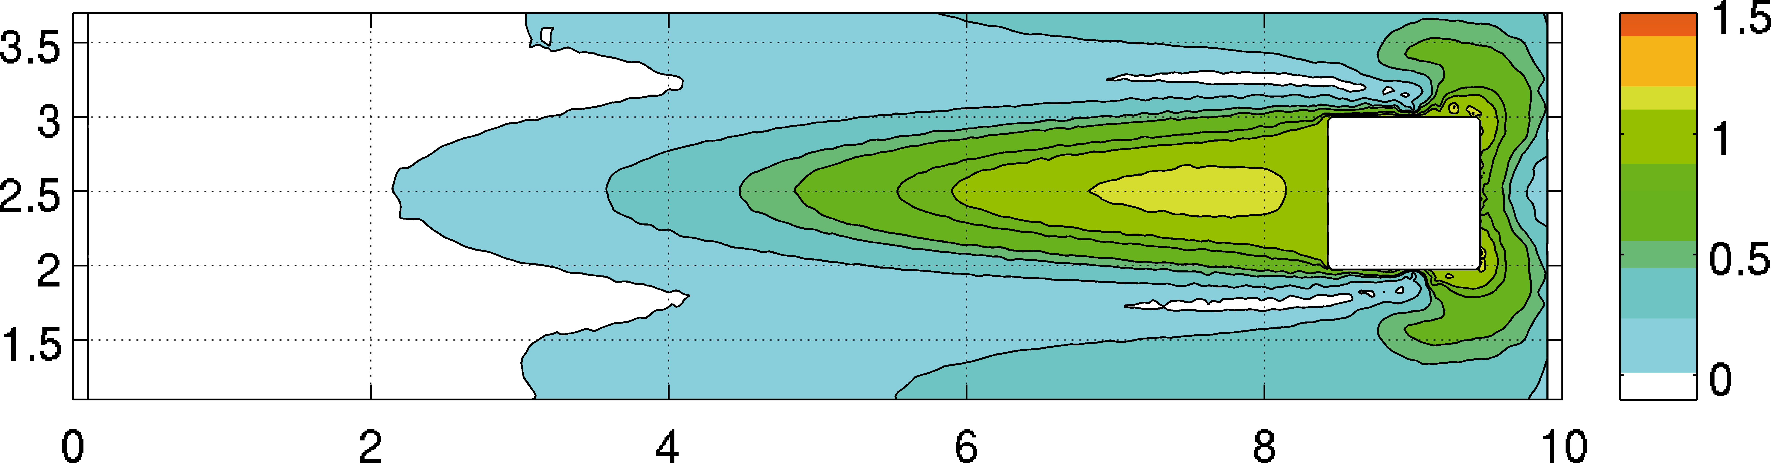  (a) Velocity magnitude | 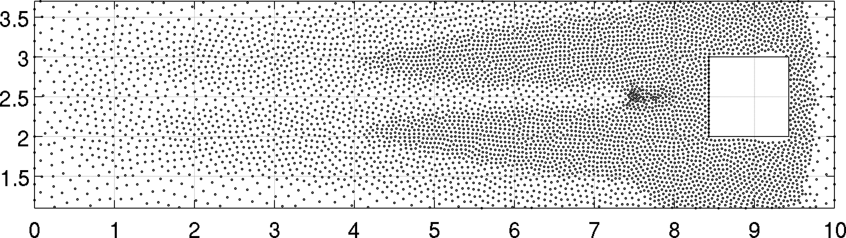  (b) Particle position
Figure 1 – Moving Square test case at time 8s, with initial particle spacing Δx=0.2 m.

[1] S. Børve M. Omang, J. Truslen (2005). Regularized smoothed particle hydrodynamics with improved multi-resolution handling, Journal of Computational Physics 208 345-367.
[2] R. Vacondio, B. D. Rogers, and P. K. Stansby, (2011). Accurate particle splitting for SPH in shallow water with shock capturing. International Journal for Numerical Methods in Fluids, doi: 10.1002/fld.2646.

